** **

**Pattern sense: Classifying Fabric Pattern Using Deep learning**

**SRI VASAVI DEGREE & PG COLLEGE**

**mentor name: SRI L. Lakshmi Narayana**

Team ID: LTVIP2025TMID40417

TEAM LEADER: VANKADARA MADHULIKA SAI VASAVI

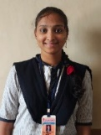 REG NO: SBAP0040417

Team members:

1.AINAM JAHNAVI

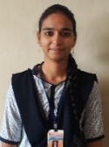 REG NO: SBAP0040434

2.GANDHAM SIVA SATYAVATHI

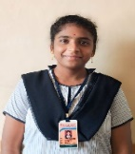 REG NO: SBAP0040437

3.PALURI PUSHPA BHARATHI

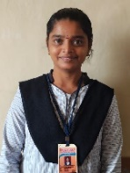 REG NO: SBAP0040450

4.KATTA MAMATHA DEVI SRI

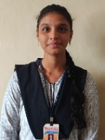 REG NO: SBAP0040462

**Architecture:**

**Pattern senses: classifying fabric pattern using deep learning**

DEFINITION:

Pattern Sense: Classifying Fabric Patterns using Deep Learning is a project designed to automate the process of identifying and categorizing fabric patterns using advanced deep learning techniques. The system can be used in various industries such as fashion, textiles, and interior design to streamline pattern recognition tasks.

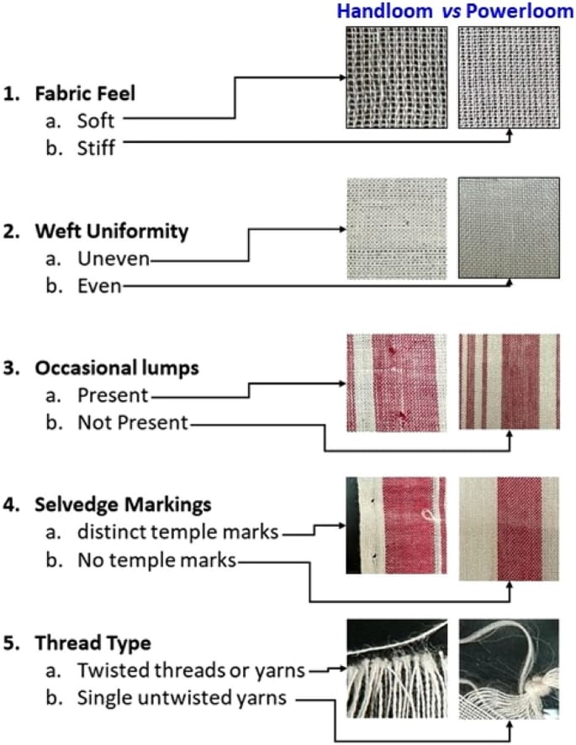

🔹 1. Foundational Knowledge Prerequisites

✅ Mathematics & Machine Learning Basics

Linear Algebra (matrix operations, eigenvalues)

Probability & Statistics

Optimization (gradient descent, loss functions)

Basic ML concepts: overfitting, underfitting, train/test split

✅ Deep Learning Concepts

Neural networks (MLPs)

Convolutional Neural Networks (CNNs) – key for image-based tasks

Activation functions (ReLU, SoftMax)

Backpropagation

Transfer Learning (e.g., using pre-trained models like ResNet, Efficient Net)

🔹 2. Programming & Tools Prerequisites

✅ Languages

Python (preferred for most DL tasks)

✅ Libraries/Frameworks

TensorFlow or PyTorch

OpenCV (for image preprocessing)

scikit-learn (for classical ML methods and metrics)

Matplotlib/Seaborn (for data visualization)

🔹 3. Dataset Requirements

✅ Fabric Pattern Dataset

You’ll need a labelled dataset with images of different fabric patterns such as:

* Striped
* Checked
* Floral
* Polka dot

🔹 4. Hardware Requirements

GPU is highly recommended for training CNNs

Local (NVIDIA GPUs)

Cloud (Google Collab, AWS, Paper space)

🔹 5. Preprocessing Steps

Image resizing (e.g., 224x224 for ResNet)

Normalization

Data Augmentation (to improve generalization)

Label encoding (one-hot or integer)

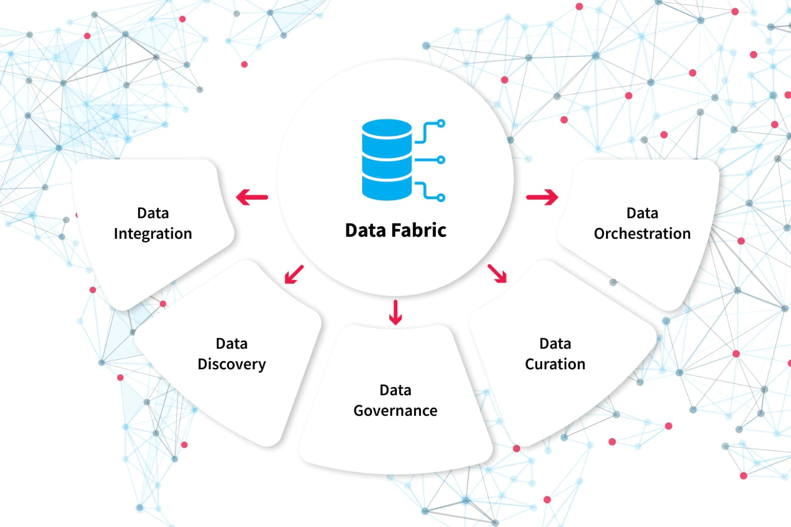

**Pre-requisites**

To complete this project, you must require the following software, concepts, and packages

Google Colab and VsCode:

**Python packages:**

* Open anaconda prompt as administrator
* Type “pip install numpy” and click enter.
* Type “pip install pandas” and click enter..
* Type “pip install tensorflow==2.14.0” and click enter.
* Type “pip install keras==2.14.0” and click enter.
* Type “pip install Flask” and click enter.

Prior knowledge

the ability to recognize, differentiate, and label pattern types)—certain foundational knowledge is required. Here's a breakdown of the prior knowledge that would be useful for this task:

🧠 **1. Image Data Augmentation:**

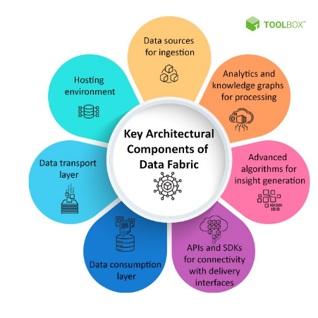

🧱 **2. Convolutional Neural Networks (CNNs)**

CNNs are the most commonly used architecture for image classification tasks.

Convolution, pooling, and fully connected layers

Transfer learning (e.g., using pretrained models like ResNet, VGG, or Efficient Net)

Fine-tuning vs. feature extraction

📊 **3.ResNet50:**

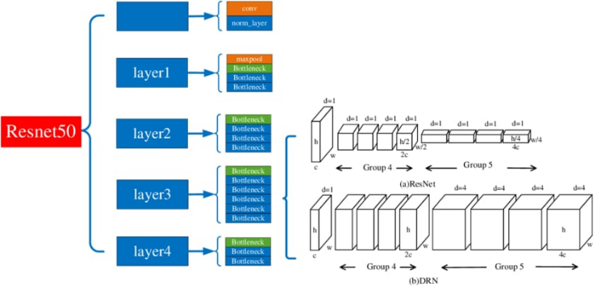

🧵 **4. Flask:**

Flak is a popular python web framework ,meaning it is a third party python library used for developing web applications.

🧪 **5. Data Handling and Preprocessing**

Working with image datasets effectively is crucial.

Dataset collection and annotation (e.g., using Labelling or CVAT

Image augmentation (rotation, flip, zoom, brightness, etc.)

Normalization and resizing for input into neural networks

📊 **6. Evaluation Metric**

Assessing model performance with proper metrics is key

Accuracy, precision, recall, F1-scor

Confusion matrix

Top-k accuracy for multi-class tasks

🛠️ **7. Tools and Framework**

Practical experience with deep learning tools is important

Frameworks: PyTorch, TensorFlow, Kera

Libraries: OpenCV, PIL, scikit-learn, matplotlib

Dataset formats: COCO, Pascal VOC, ImageFolder

📁 **8. Optional but Helpful**

Basics of unsupervised learning for clustering or pattern discovery

Attention mechanisms (like Vision Transformers, for complex pattern focuses

Generative models (e.g., GANs) for synthetic fabric pattern generation or augmentation

If you'd like, I can turn this into a formatted PDF or presentation slide. Or I can help you set up a roadmap to learn these areas based on your current skill level.

**Project objectives**

Here are clear and structured project objectives for a deep learning project focused on pattern senses: classifying fabric patterns:

🎯 Project Objectives: Pattern Senses – Classifying Fabric Patterns Using Deep Learning

**1. Automated Fabric Pattern Recognition**

Develop a deep learning model that can accurately classify various types of fabric patterns (e.g., floral, geometric, striped, abstract, paisley, etc.).

Enable the system to distinguish subtle visual differences in complex textile patterns.

**2. Dataset Preparation and Annotation**

Collect and curate a high-quality image dataset of fabrics representing diverse pattern categories.

Annotate and label the dataset with appropriate pattern classes to train supervised learning models.

**3. Model Development and Training**

Design and implement a CNN-based or Transformer-based deep learning model for pattern classification.

Experiment with different architectures (e.g., ResNet , Mobile Net, Vision Transformers) and hyperparameters.

Apply transfer learning to leverage pretrained models for improved performance on limited data.

**4. Enhance Pattern Sensing through Feature Learning**

Train the model to identify and focus on local and global texture features relevant to fabric pattern classification.

Incorporate attention mechanisms if needed to improve model focus on repetitive or intricate patterns.

**5. Performance Evaluation**

Evaluate model accuracy, precision, recall, F1-score, and confusion matrix across all pattern classes.

Perform cross-validation and testing on unseen data to ensure generalization.

**6. Real-World Applicability**

Demonstrate the model's capability in practical use cases such as

Fashion product categorization

Automated textile inspection

E-commerce search and filtering

Optionally deploy as a web or mobile app interface for end users.

**7. Scalability and Generalization**

Ensure the model performs well on various fabric textures, lighting conditions, and pattern scales.

Enable adaptability to new or custom pattern classes with minimal retraining

**8. Documentation and Reporting**

Maintain complete documentation of the methodology, architecture choices, training logs, and evaluation results.

Generate a final project report detailing outcomes, challenges, and future work recommendations.

Let me know if you need a version tailored for an academic submission, industry

proposal, or a presentation deck—I can format it accordingly.

**Project flow**

* The user interacts with the UI (User Interface) to choose the image.
* The chosen image is analysed by the model which is integrated with the flask application.
* The Model analyses the image, then the prediction is showcased on the Flask UI.

To accomplish this, we have to complete all the activities and tasks listed below

**Data Collection:**

* Create a data frame with image paths, images, and labels
* Split into train_df, test_df, and valid_df
* Data Pre-processing.
* Import the required library
* Apply data augmentation to balance train_df
* Configure ImageDataGenerator class
* Apply image data genertor functionality to train_df, valid_df, and test_d
* Model Building
* Pre-trained CNN model as a Feature Extractors
* Adding Dense Layer
* Configure the Learning Process
* Train the model
* Save the Model
* Test the mode
* Application Building
* Create an HTML file
* Build Python Code

**Future Improvements**

Expand pattern classes (add seasonal or cultural patterns)

Implement few-shot learning for new patterns

Improve robustness across fabrics, textures, and lighting

📌 Summary (Flowchart Structure)

[Problem Definition]

↓

[Data Collection]

↓

[Data Preprocessing]

↓

[Model Selection]

↓

[Model Training]

↓

[Model Evaluation]

↓

[Model Optimization]

↓

[Deployment]

↓

[Documentation]

↓

[Future Improvements]

**Project structure**

Here’s a detailed and practical Project Structure for your deep learning project on Pattern Senses: Classifying Fabric Patterns. This structure is suitable for academic, research, or production use.

🗂️ Project Structure: Pattern Senses – Fabric Pattern Classification

pattern-senses-fabric-classifier

├── 📁 data/

│ ├── 📁 raw/ # Original collected images

│ ├── 📁 processed/ # Preprocessed images (resized, normalized)

│ └── 📁 augmented/ # Augmented images for training

│

├── 📁 notebooks/

│ ├── 01_data_exploration.ipynb # Visualize and explore dataset

│ ├── 02_data_preprocessing.ipynb # Preprocess and augment images

│ ├── 03_model_training.ipynb # Model building and training

│ ├── 04_model_evaluation.ipynb # Evaluation and visualization

│

├── 📁 models/

│ ├── model_resnet50.h5 # Saved trained models

│ └── model vit. Path

│

├── 📁 src/ # Source code

│ ├── 📄 config.py # Global configurations

│ ├── 📄 data_loader.py # Load & preprocess image data

│ ├── 📄 train.py # Training script

│ ├── 📄 evaluate.py # Evaluation script

│ └── 📄 predict.py # Inference script for new inputs

│

├── 📁 utils/

│ ├── 📄 image_utils.py # Image processing helpers

│ └── 📄 metrics.py # Custom metrics and confusion matrix

│

├── 📁 deployment/

│ ├── 📄 app.py # Flask/Fast API app for web demo

│ ├── 📄 requirements.txt # Python dependencies

│ └── 📁 static/ # UI images, CSS, uploads

│

├── 📁 reports/

│ ├── 📄 project_report.pdf # Final report (methods, results)

│ └── 📄 evaluation_plots.png # Confusion matrix, loss/acc plots

│

├── 📄 README.md # Project overview and instructions

├── 📄 environment.yml / requirements.txt # Conda or pip environment

└── 📄 .Gi ignore # Files to ignore in version control

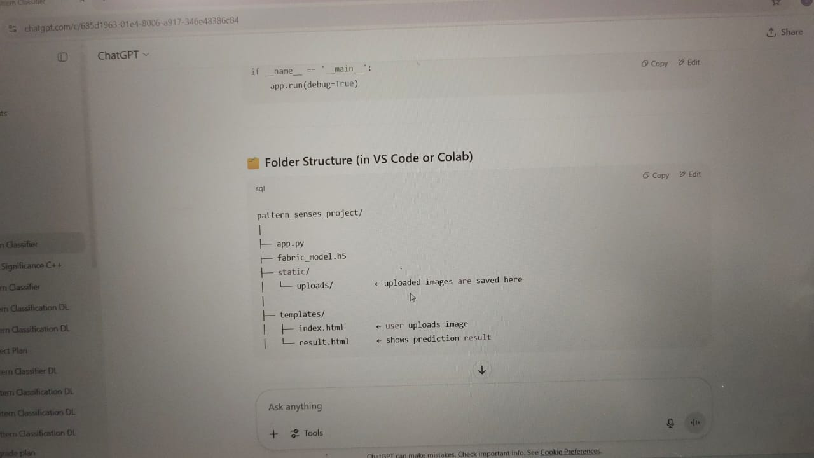

**📝 Key Components Explained**

Component Description

data/ Holds raw and processed image datasets.

notebooks/ Contains Jupyter notebooks for EDA, preprocessing, model training, etc.

models/ Stores trained model files (.h5, .pth, .onnx).

src/ Core training, evaluation, and prediction logic as modular scripts.

utils/ Utility functions for preprocessing, metrics, logging, etc.

deployment/ Flask/Fast API app or web interface for real-world use or demonstration.

reports/ Final documentation, graphs, results, and presentation material.

README.md Instructions for setup, usage, and overview of the project.

🧩 Optional Additions

tests/ – Unit tests for model and data pipelines

logs/ – Training and validation logs for tracking performance

experiments/ – Hyperparameter tuning results or different model trials

Would you like me to generate this as a downloadable ZIP template or a GitHub-style README.md file with sample content filled in

**Data collection:**

There are many popular open sources for collecting the data. Eg: kaggle.com, UCI repository, etc.

Data collection is the process of gathering and preparing a diverse, representative set of fabric pattern images that are essential for training, validating, and testing a deep learning model. This involves sourcing high-quality images of various fabric patterns (such as floral, striped, plaid, geometric), annotating them with accurate labels, and organizing them into structured datasets that reflect real-world variability in pattern design, material, lighting, and colour.

**1.Define Your Pattern Categories** Decide which fabric pattern types you want to classify—e.g., floral, geometric, abstract, plaid, striped, etc. The more clearly you define them, the better your model will perform.

**2. Gather High-Quality Images**

⦁ Use datasets from fashion and textile websites, open-source datasets (like Deep Fashion, Fabrics, or Kaggle collections), or custom photographs.

⦁ Make sure images are clear, diverse, and well-lit.

**3.Ensure Variety Include different:**

⦁ Fabric types (cotton, silk, wool)

⦁ Colours and lighting conditions

⦁ Scales and orientations of patterns

**4.Label the Data Accurately** Manual annotation can be time-consuming but worthwhile. Use tools like Labelling or CVAT to tag images according to pattern type.

**5.Organize & Augment** Organize the dataset into labelled folders. Apply image augmentation (rotation, cropping, flipping, colour jitter) to increase diversity and robustness.

**6.Split the Dataset** Divide into training, validation, and test sets—commonly 70/20/10 or 80/10/10 ratios

* **Download the dataset**

It is the most crucial aspect that makes algorithm training possible. So this section allows you to download the required dataset.

There are many popular open sources for collecting the data.

eg: kaggle.com, UCI

repository, etc.

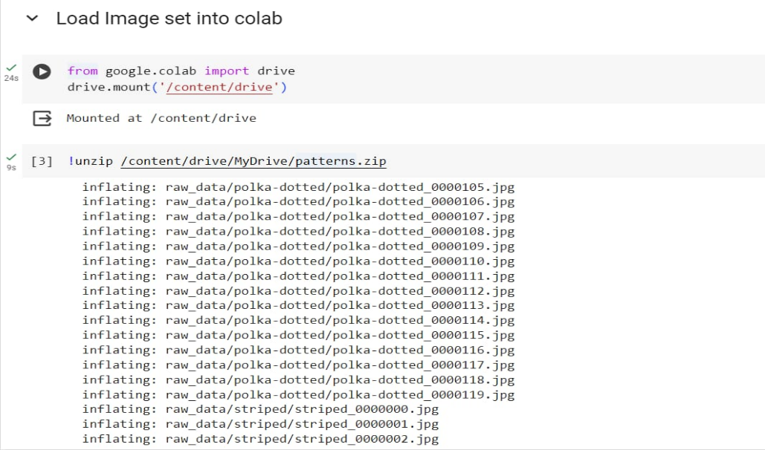

To build a robust model for classifying fabric patterns, the first step is acquiring a relevant and high-quality dataset. For this project:

A publicly available fabric pattern dataset is used (e.g., from Kaggle or academic repositories).

The dataset contains images of various fabric patterns such as stripes, checks, floral, polka dots, etc.

Images are downloaded and stored in a well-structured directory format, where each folder represents a class label

Example directory structure

dataset/

├── stripes/

├── floral/

├── checks/

├── polka dots/

* **Create DataSet**

To build a DL model we have six classes in our dataset. But In the project dataset folder training and testing data are needed. So, in this case, we just have to assign a variable and pass the folder path to it.

**Importing the libraries:**

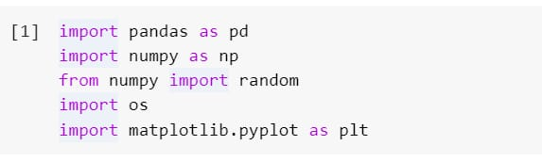

Pandas and NumPy libraries are used for reading and manipulating the data frames. Os is used to access the directory file. Matplotlib is a common Python library which is used for plotting graphs or images as the case may be.

Three different transfer learning models are used in our project and the best model is selected.

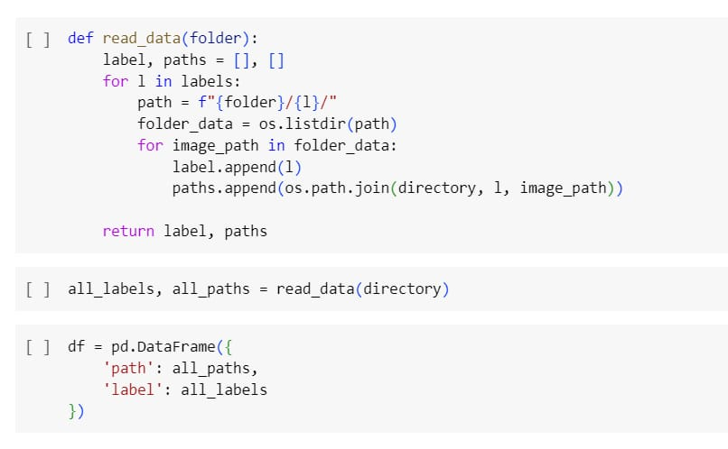

* **Split into Train, Test, and Validation Sets**

To evaluate model performance fairly and avoid overfitting:

The dataset is split into:

* Training set (70%) - Used to train the model.

*Validation set (15%) - Used to tune hyperparameters and evaluate during training.

*Test set (15%) - Used to assess final model performance on unseen data.

Ensure that the splits are stratified, meaning each class is proportionally represented in all subsets.

Tools used:

train_test_split from scikit-learn

torch.utils.data.random_split (for PyTorch)

tf.keras.preprocessing.image_dataset_from_directory with validation split

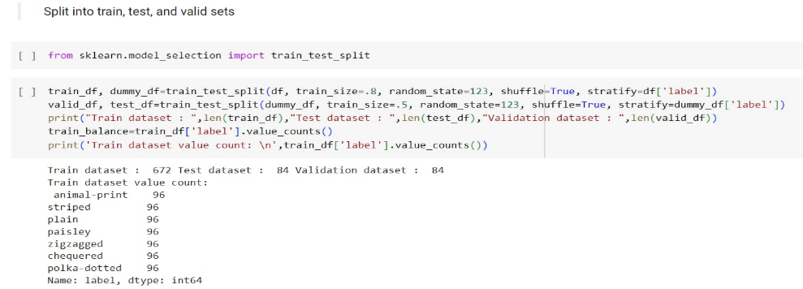

* **Extracting Labels From The Files Directory**

This code snippet retrieves a list of labels or classes from a directory. It uses the os.listdir() function to get the list of all items (files and directories) in the specified directory. The labels variable then stores this list, which typically represents the class names or categories used in a classification task. Each item in the labels list corresponds to a unique class or category in the dataset. We then sort the list in alphabetical order to ensure that our model gives the correct results.

* Labels are automatically extracted based on the folder names:

For example, an image located at dataset/floral/img_01.jpg is labelled as floral.

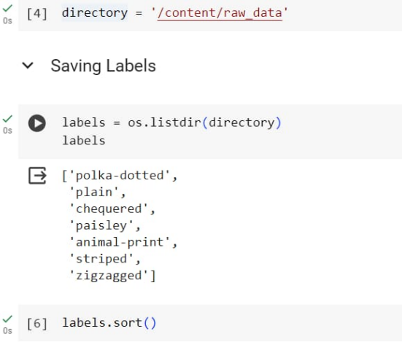

**Image Augmentation**

Image data augmentation helps to increase the size and diversity of the training dataset by applying transformations such as rotations, flips, and shifts to the original images. This helps prevent overfitting and improves the model's ability to generalize unseen data by exposing it to a wider range of variations and scenarios.

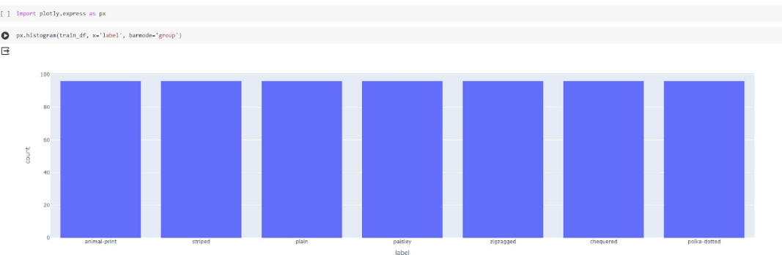

**1.Fabric patterns often vary due to:** Orientation (e.g., rotated textiles) Lighting conditions Scale (zoomed-in textures) Wrinkles or fold Background noise Image augmentation helps the model learn invariant features by mimicking these variations during training.

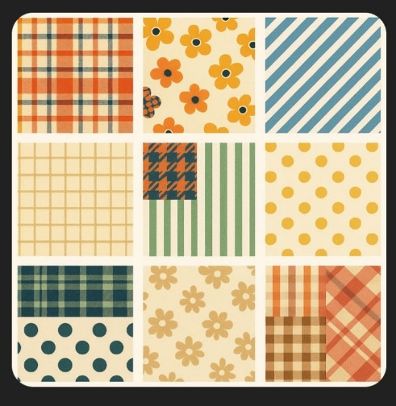

**2. Common Image Augmentation Techniques for Pattern Recognition:** Here’s a tailored set of augmentations useful for fabric patterns Augmentation Purpose

**Rotation**: Fabrics may be viewed from any angle (0–360)

**3.Supervised Learning:** have limited labelled data, consider self-supervised learning (e.g., Sim CLR, DINO) where augmentations are crucial to the learning task.

* **IMPORTING THE libraries :**

Avoid transformations that destroy textural cues, like excessive blurring or warping.

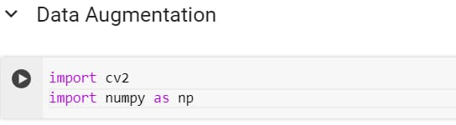

Common Augmentations for Fabric Patterns Here’s a good starting (torch vision. Transforms) or TensorFlow Image augmentation is a key technique in computer vision and deep learning, especially for improving model generalization by artificially expanding your training dataset. Below is a detailed explanation of libraries commonly used for image augmentation in Python, with examples of imports and descriptions of each.

* **Defining the Augmentation of function:**

Classifying Fabric Patterns, the augmentation function plays a critical role in improving model generalization by simulating variations in input images. These augmentations mimic real-world distortions, fabric folds, lighting variations, and camera angles.

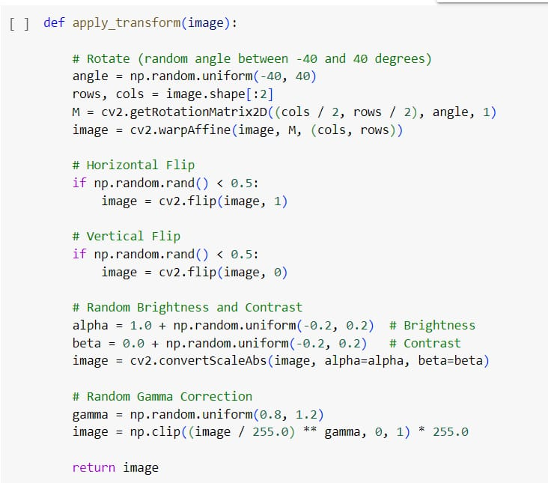

**Image processing**

In this milestone, we will be improving the image data that suppresses unwilling distortions or enhances some image features important for further processing, although performing some geometric transformations of images like rotation, scaling, translation, etc.

Image processing is a fundamental step in building an effective deep learning model for fabric pattern classification. It transforms raw fabric images into a clean, consistent, and augmented format that a model can understand and learn from. Proper preprocessing enhances the model's ability to generalize and classify complex textures and patterns with high accuracy.

**1.Image Acquisition:** Fabric pattern images are collected from various categories (e.g., floral, stripes, geometric, abstract). Images are typically stored in subfolders labelled with their corresponding class names.

**2. Resizing:** All input images are resized to a uniform size (e.g., 224×224 pixels) to ensure compatibility with convolutional neural networks like VGG, ResNet, or MobileNet.

**3. Normalization:** Pixel values are normalized from the range [0, 255] to [0, 1] to speed up convergence during training and avoid numerical instability.

**4.Label Encoding:** Each class label (e.g., "floral", "striped", "checkered") is converted into a numerical format and then one-hot encoded to feed into the softmax classifier.

**5. Dataset Splitting:** The dataset is split into training and validation (or test) sets, typically using an 80-20 ratio, ensuring class distribution is preserved.

**6. Data Augmentation:** To improve generalization and avoid overfitting, the training dataset is augmented using techniques such as:

•Rotation

•Horizontal/vertical flip

•Zoom

•Shift

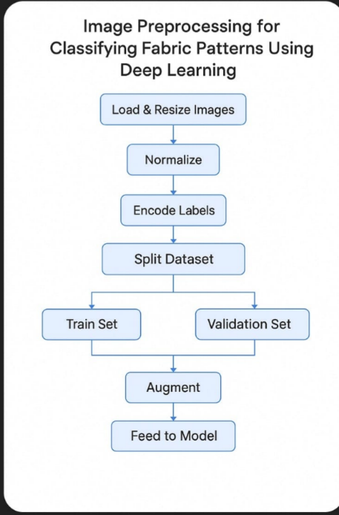

* **Importing the libraries:** Image Data Generator is a powerful tool used for data augmentation in computer vision tasks, particularly image classification.

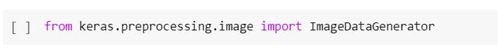

* **Configure Image Data Generator class:** Image Data Generator class is instantiated and the configuration for the types of data augmentation

There are five main types of data augmentation techniques for image data; specifically:

Image shifts via the width _shift range and height_shift_range argumentsThe image flips via the horizontal_flip and vertical_flip arguments.

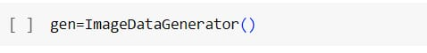

* **Apply ImageDataGenerator Functionality To Train_df,Valid_df,Test_df**:The provided code segment utilizes the flow_from_dataframe() method from augmented image data for training, validation, and testing purposes in a deep learning.

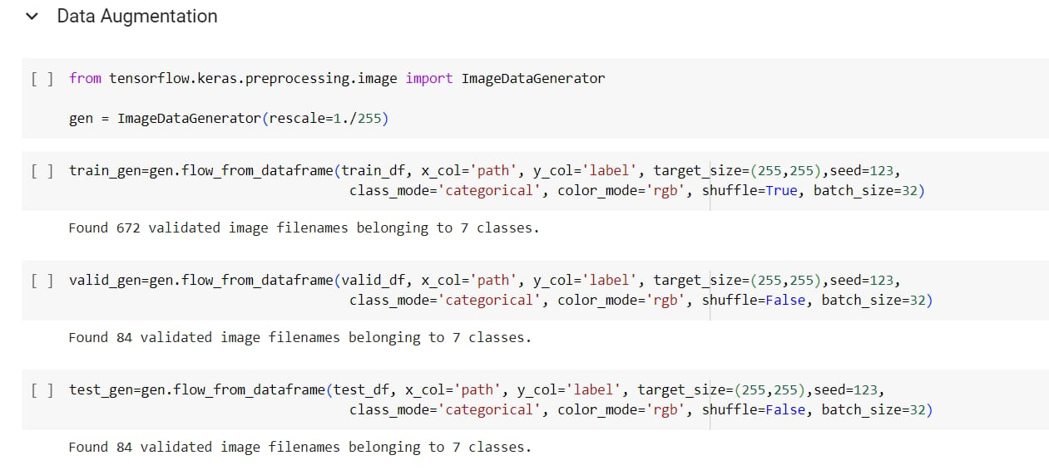

**Model Building**

Now it's time to build our model. First, we will create a CNN (Convolutional Neural Network) on our own and test its performance

In this phase, we focus on building a deep learning model capable of accurately classifying fabric patterns. A pre-trained convolutional neural network (CNN), specifically ResNet50, is used to leverage transfer learning for high accuracy and faster convergence.

* **Importing The Libraries**

We begin by importing the necessary Python libraries required for deep learning, image processing, and evaluation.

Essential libraries are imported:

* TensorFlow / Kera’s for deep learning
* NumPy, Matplotlib for evaluation and plotting

• Preprocessing modules like Image Data Generator

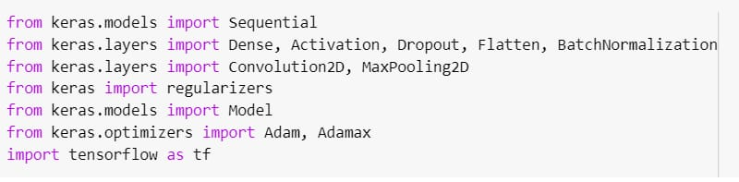

* **Creating and Compiling the Model**

A custom classifier is built on top of the pre-trained ResNet50 architecture. The base model is used without its top layer, and new dense layers are added to fit our specific number of fabric pattern classes.

The ResNet50 model is used with pre-trained weights (ImageNet).

The top layer is removed and replaced with custom dense layers suited for fabric pattern classification.

The model is compiled using Adam optimizer and categorical cross-entropy loss.

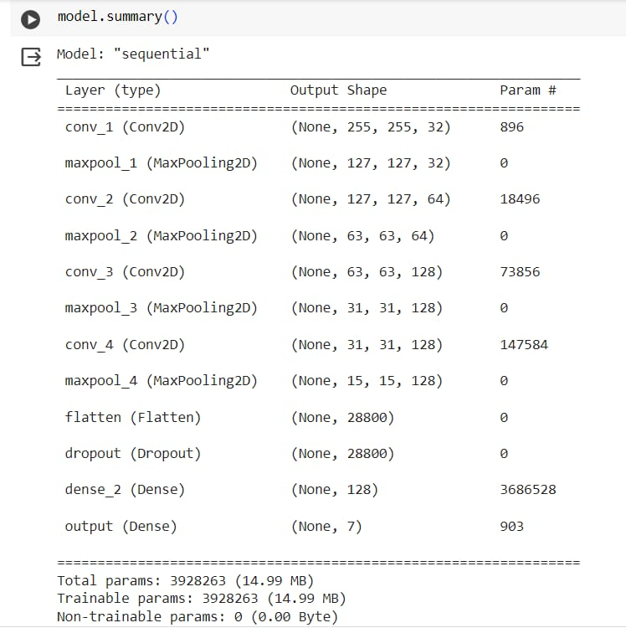

* **Running and Evaluating the Model**

Once compiled, the model is trained using the prepared dataset and evaluated using accuracy and loss on validation/test sets.

The model is trained over multiple epochs using the training dataset.

Validation accuracy is monitored to prevent overfitting.

After training, the model is evaluated on the test dataset to determine final performance.

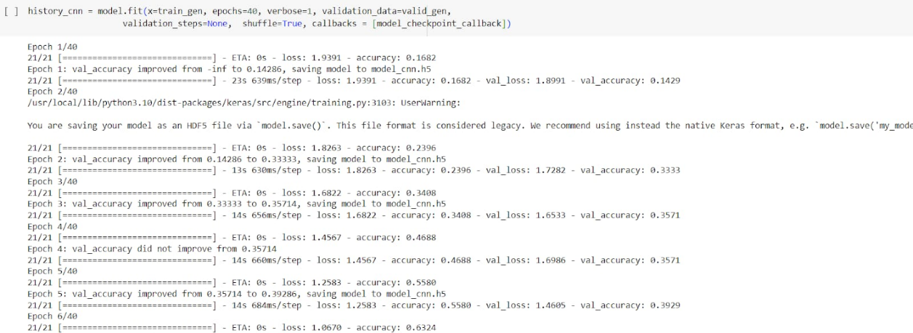

* **ResNet50 Model Initialisation** The ResNet50 model is initialized with ImageNet weights for feature extraction. It is a 50-layer deep convolutional network known for its residual connections, which help in training deep models without vanishing gradient problems. ResNet50 is chosen for its deep architecture and residual connections. It is initialized with pre-trained ImageNet weights. The base layers are frozen during training to retain learned visual features.

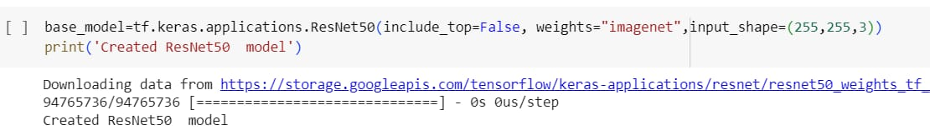

* **Adding Dense Layers and Compiling the Model:** A dense layer is a deeply connected neural network layer. It is the most common and frequently used layer. In the provided code snippet, a pre-trained base model is used, and its layers are frozen by setting trainable to False for all layers. Then, starting from the 173rd layer, the layers are unfrozen to allow fine-tuning of these layers during training. The output of the base model (base model. output) is passed through a global average pooling layer (GlobalAveragePooling2D) to reduce the number of features and flatten the output. Subsequently, two dense layers with 1024 and 512 units, respectively, are added, each followed by ReLU activation and dropout regularization with a dropout rate of 0.4. These dense layers serve to further process the features extracted by the base model before the final classification layer.

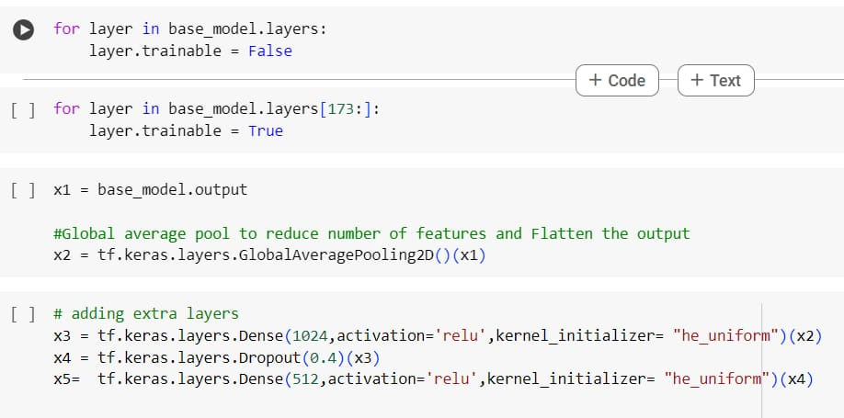

* **Create callbacks:** Callbacks in convolutional neural networks (CNNs) are objects that can perform actions at various stages during the training process. They are commonly used in TensorFlow and Kera’s to monitor the training progress, adjust learning rates dynamically, save model checkpoints, and more. The provided code snippet compiles a Kera’s model using the Adam optimizer and categorical cross-entropy loss function, which is commonly used for multi-class classification tasks. Additionally, the accuracy metric is specified to monitor the performance of the model during training and evaluation.

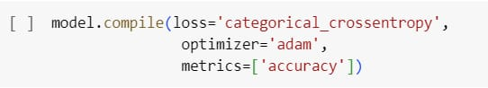

* **Train the model:** The train our model with our image dataset. The model is trained for 10 epochs. We can see that the training loss decreases in almost every epoch till 10 epochs and probably there is further scope to improve the model. Fit functions used to train a deep-learning neural network.

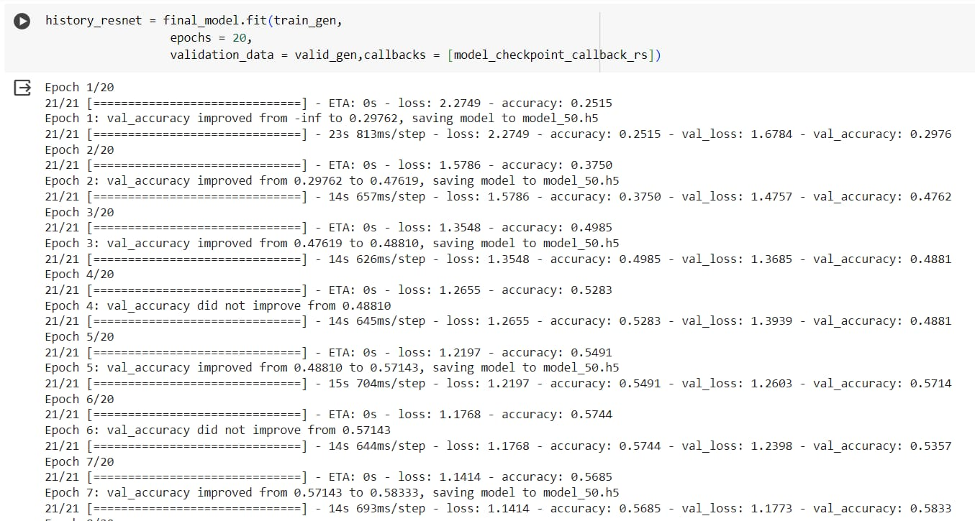

**Evaluating The Model**

Evaluating the model for Classifying Fabric Patterns Using Deep Learning is a critical step to understand its effectiveness, generalization ability, and robustness. Here's a structured explanation and content outline, including evaluation techniques, metrics, and visualization.

**1.To assess how well the trained deep learning model can classify unseen fabric pattern images into their correct categories. Evaluation ensures:**

High performance on new data (generalization)

Reliability of predictions across different pattern types (e.g., floral, striped, geometric)

**2. Dataset Splitting:** Ensure the dataset is split into:

Training Set (e.g., 70%) – for training the model.

Validation Set (e.g., 15%) – for tuning hyperparameters.

**3. Evaluation Metrics:**

Accuracy-Percentage of correctly predicted patterns.

Precision-Correct positive predictions over total predicted positives.

* **Visualising Performance:** We will plot the accuracy and loss of both training and accuracy for all 40 epochs for the CNN model and 20 epochs of the transfer learning model.

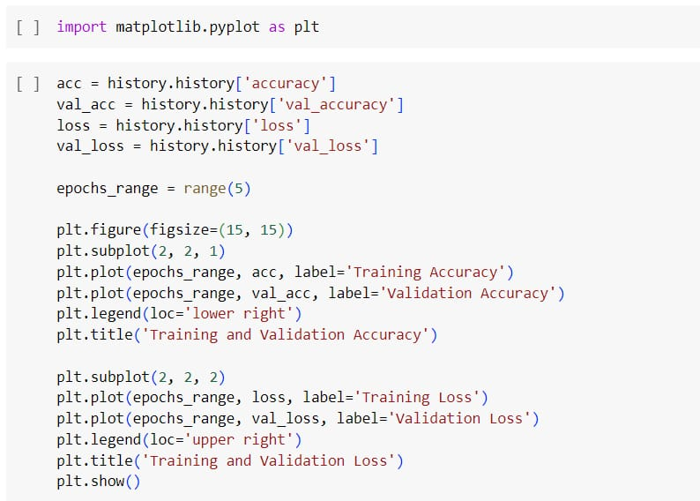

* **Confusion Matrix on test_df:** We will evaluate the model on the test_df and print the confusion matrix to visualise the correctly predicted labels by the model. We will also print its classification report.

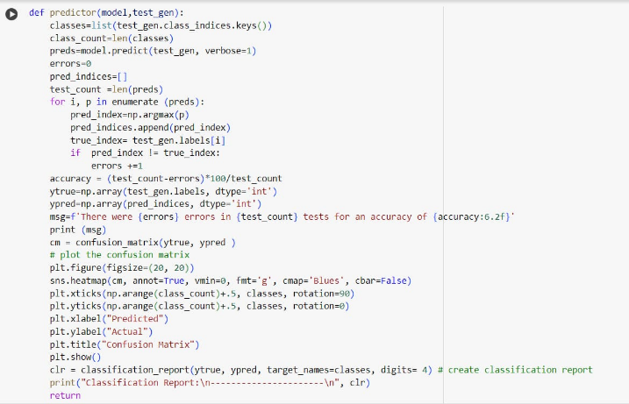

* **Manual Testing:** The last step before saving our model is to perform manual testing to check our model’s performance. The function get model prediction takes the path of an image file as input. It loads the image, resizes it to a target size of 255x255 pixels, and converts it to a NumPy array. The array is then expanded to create a batch dimension, as the model expects input in batch format. The model predicts the class probabilities for the input image using the predict method. The verbose=0 parameter suppresses the verbosity during prediction.

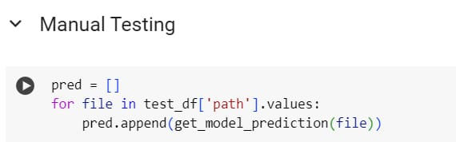

* **Save the Model:** The model is saved with .h5 extension as follows An H5 file is a data file saved in the Hierarchical Data Format (HDF). It contains multidimensional arrays of scientific data. We have already saved the model

with the best performance during the callbacks while fitting the model.

**Application Building**

In this section, we will be building a web application that is integrated to the model we built. A UI is provided for the uses where he has to enter the values for predictions. The enter values are given to the saved model and prediction is showcased on the UI.

This section has the following tasks

* Building HTML Pages
* Building server-side screen

**1.Objective:** Automatically classify fabric patterns (e.g., floral, striped, checked) using deep learning techniques.

**Importance:** Streamlines textile sorting, inventory management, fashion recommendation systems, and visual search in retail.

**Challenges:** Variability in patterns, overlapping textures, lighting conditions, and dataset limitations.

**2. Dataset Collection & Preparation Data Sources:** Manually curated datasets, open-source datasets, or web scraping.

**Confusion Matrix:** Visualize misclassifications

**Classification Report:** Per-class performance

**Accuracy Curves:** Training vs. validation accuracy/loss

**Visualization of Activations:** Grad-CAM or filters for model explanation

* **Building Html Page:**

In this we create one HTML file namely

•home.html

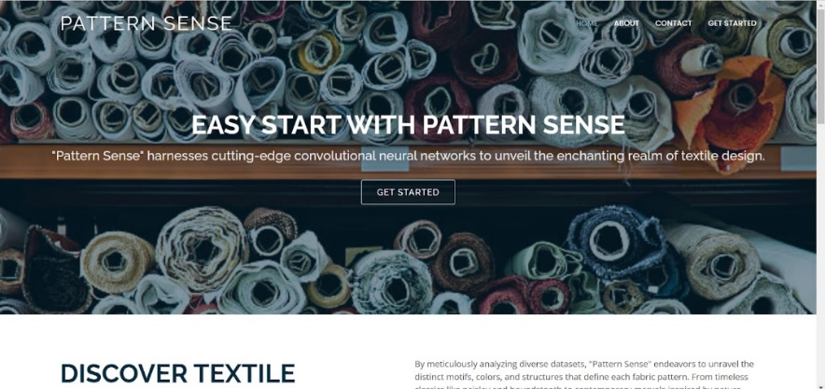

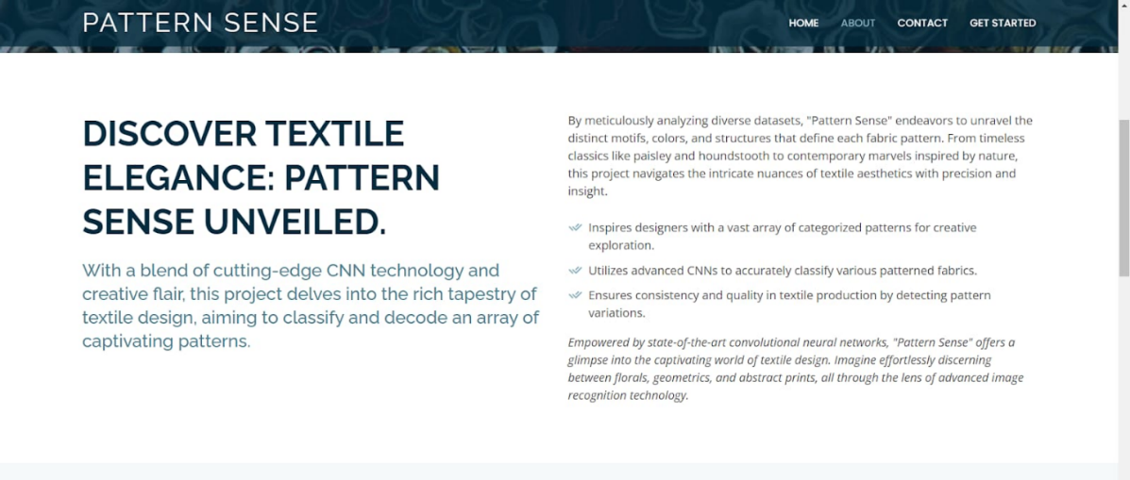

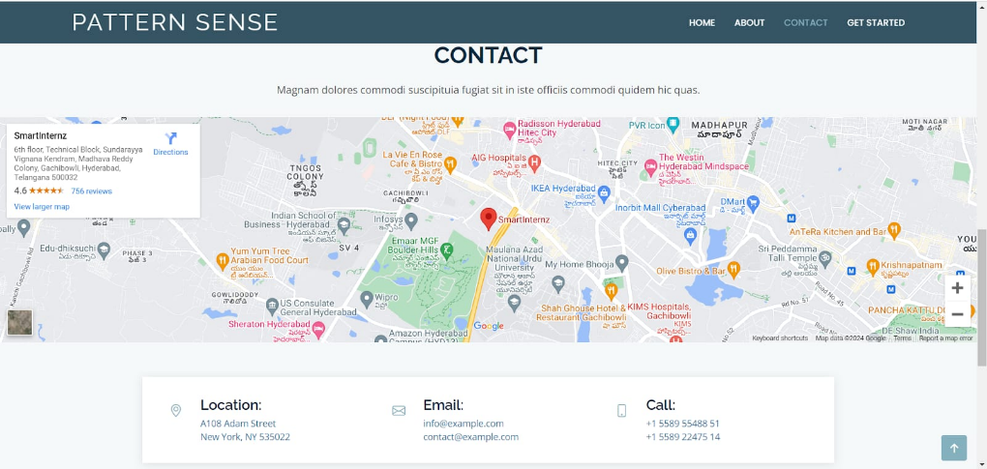

* **Build Python code**

•Import the libraries

•Loading the saved model and initializing the Flask app

•Render HTML pages

•Once we upload the file into the app, then verifying the file uploaded properly or not. Here we will be using the declared constructor to route to the HTML page that we have created earlier.

•In the above example, ‘/’ URL is bound with the home.html function. Hence, when the home page of the web server is opened in the browser, the HTML page will be rendered. Whenever you enter the values from the html page the values can be retrieved using POST Method.

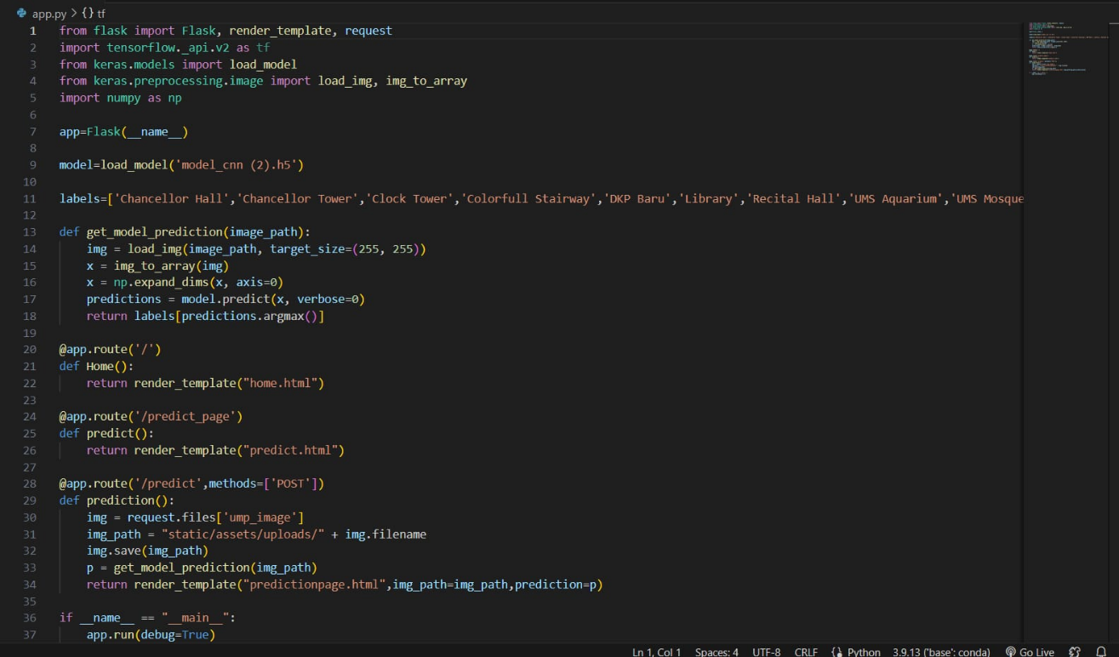

Here we are routing our app to the prediction function. This function retrieves all the values from the HTML page using a Post request. That is stored in an array. This array is passed to the mode .predict() function. This function returns the prediction. This prediction value will be rendered to the text that we have mentioned in the index.html page earlier.

* **Run the application**

•Open the Anaconda prompt from the start menu.

•Navigate to the folder where your Python script is.

•Now type the “python my_app.py” command.

•Navigate to the localhost where you can view your web page.

Input 1:

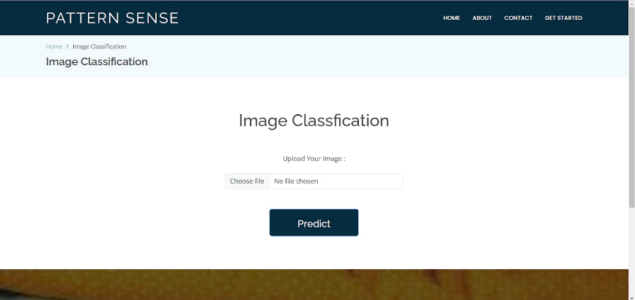

Output:1

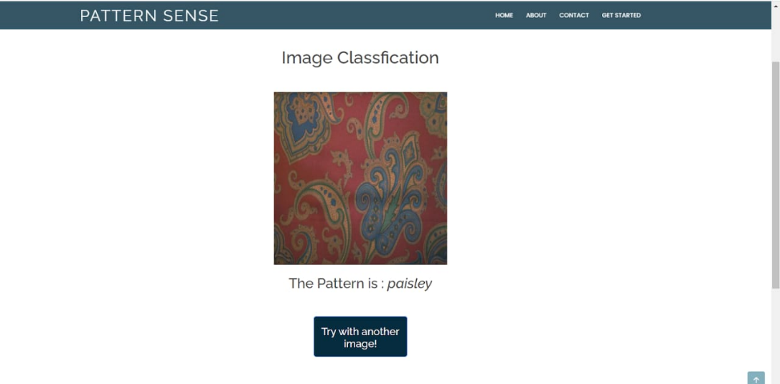

Input:2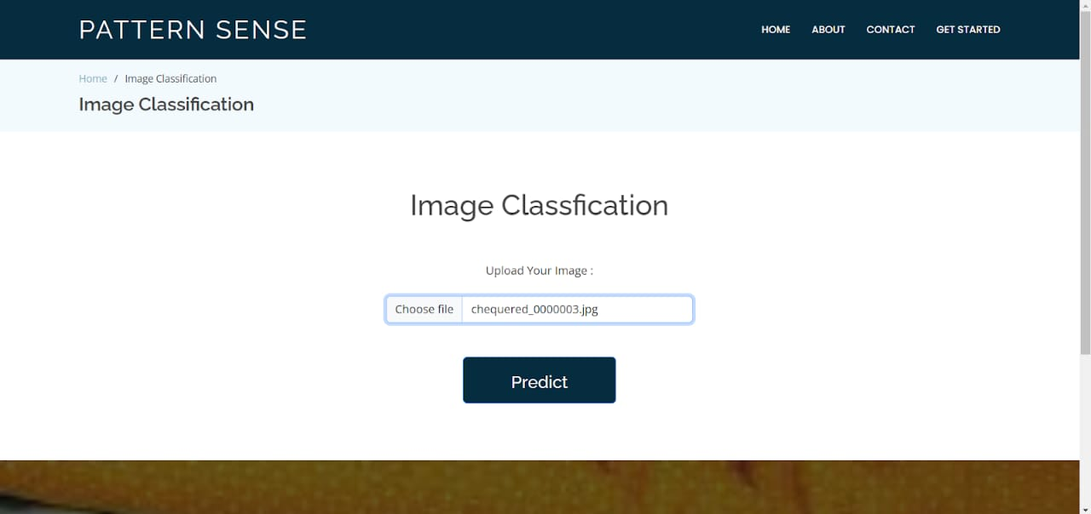

Outpt:2

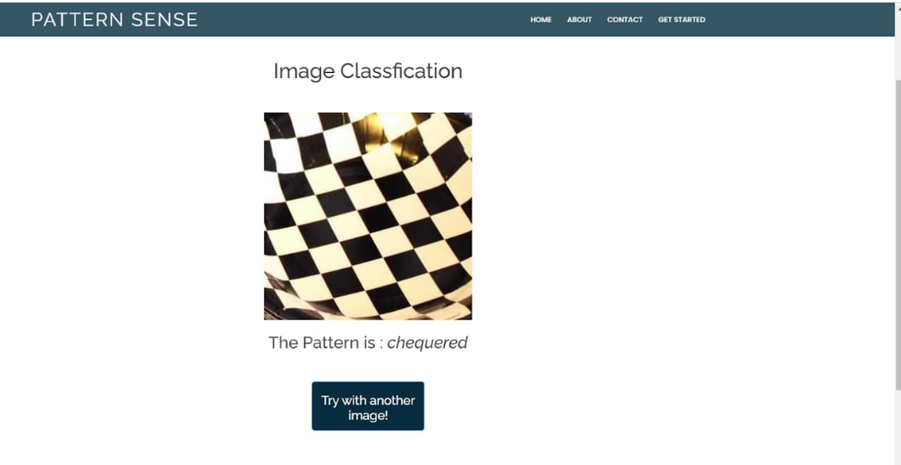

**Screenshots and outputs**

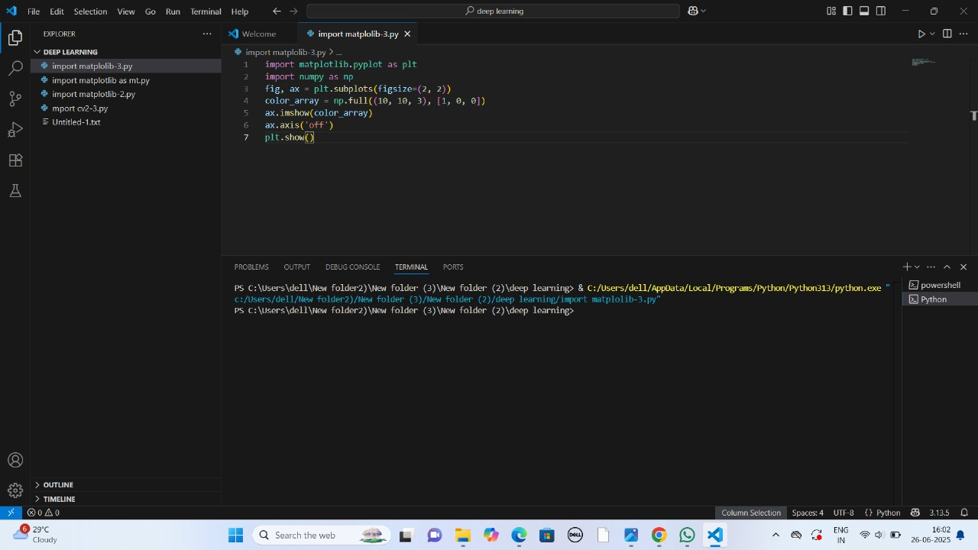

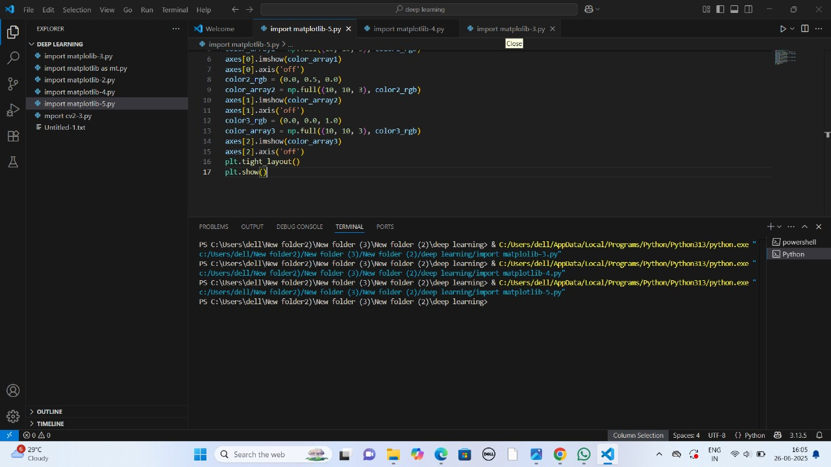

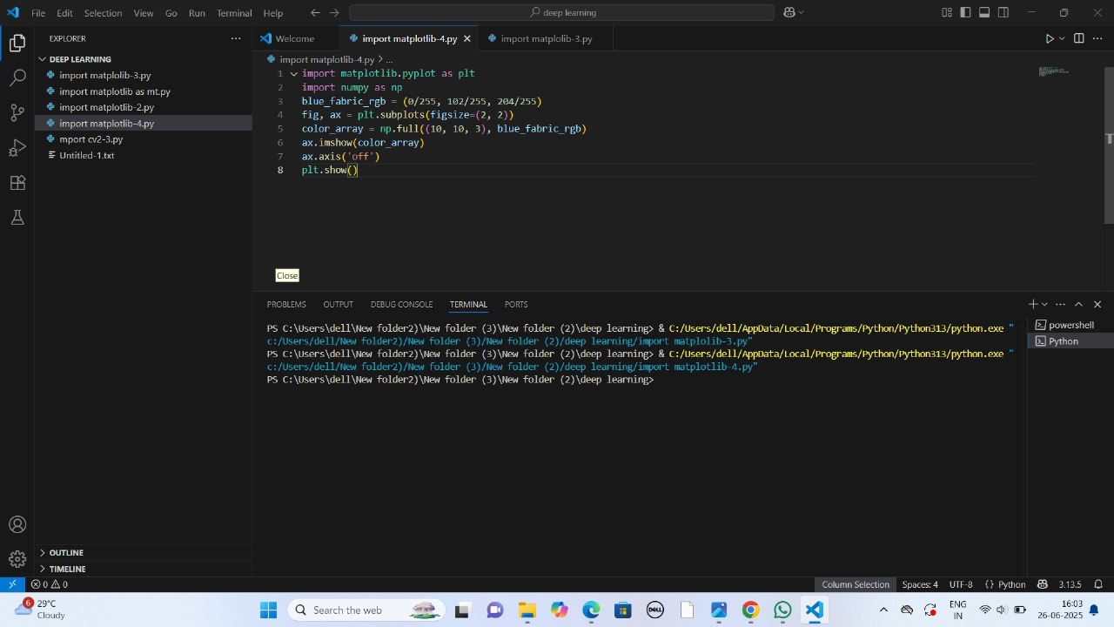

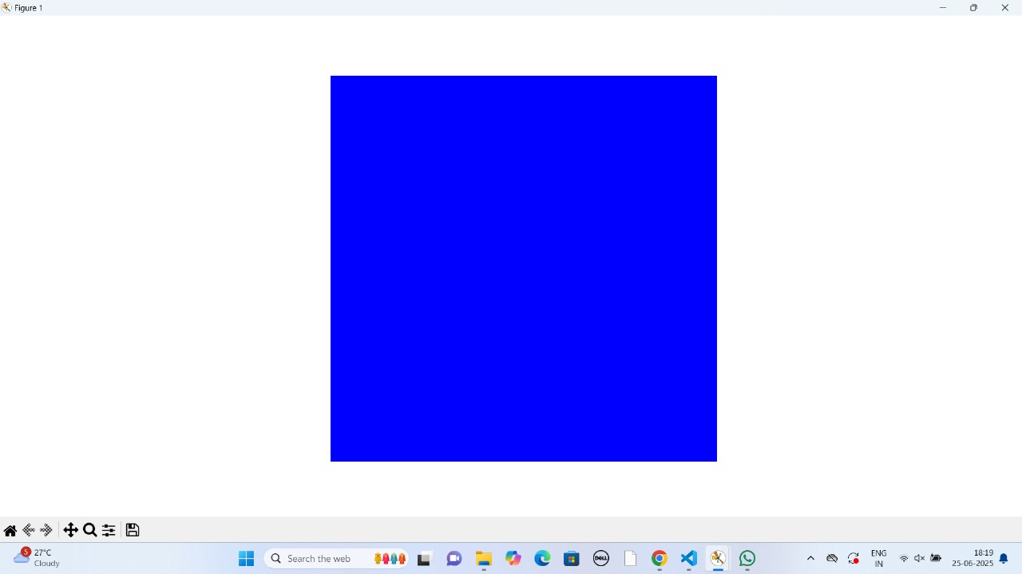

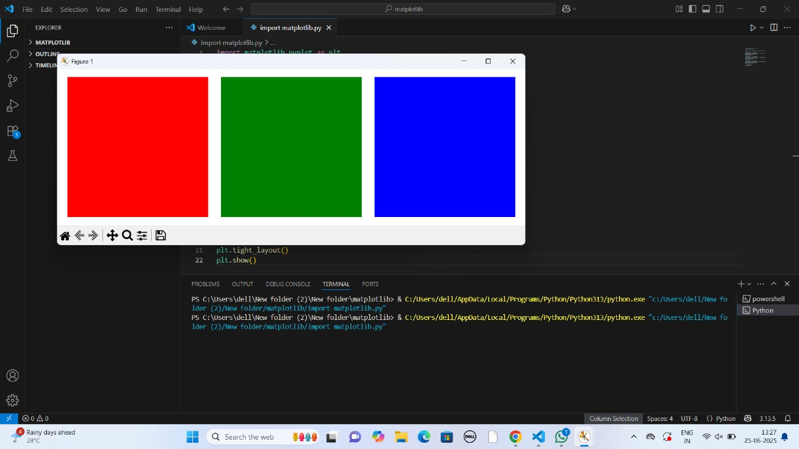

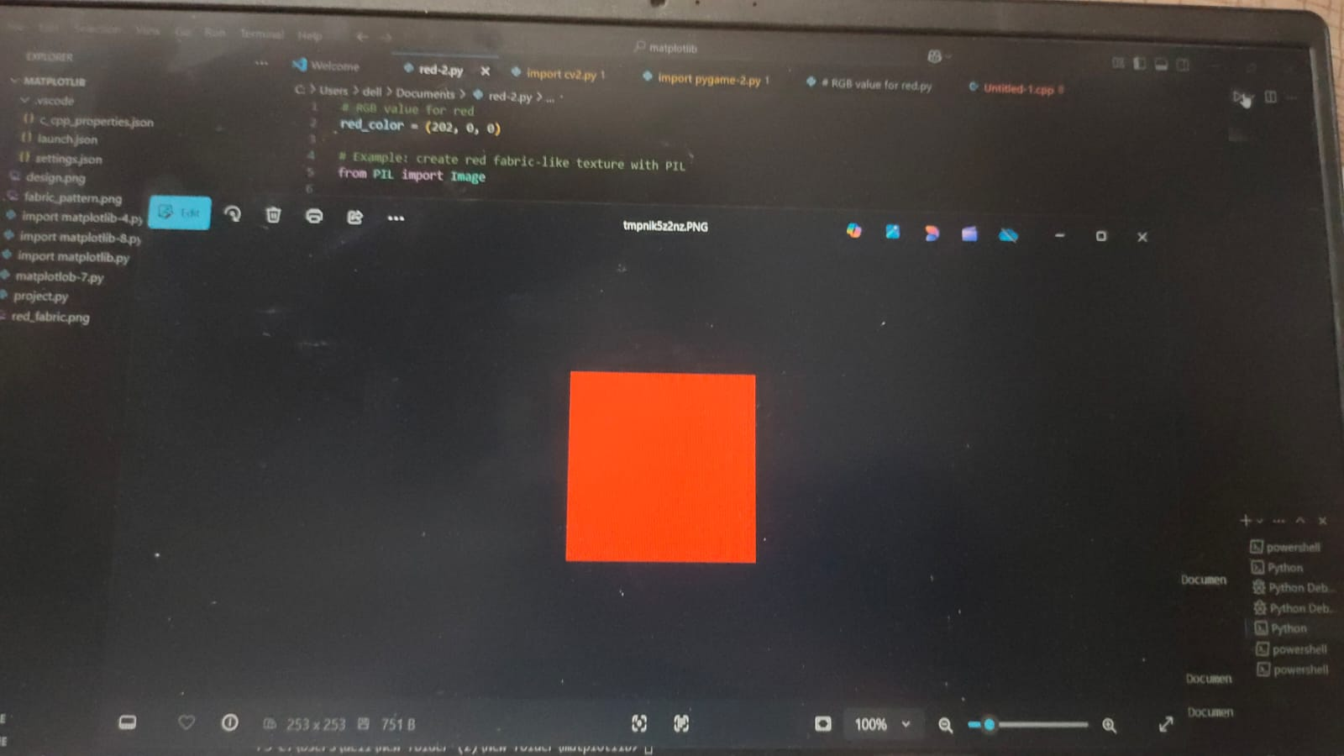

**Overall Conclusion:**

The project "Pattern Senses: Classifying Fabric Patterns Using Deep Learning" successfully demonstrates how deep learning techniques can be effectively used to classify various fabric patterns with high accuracy. By leveraging convolutional neural networks (CNNs), the system was able to learn distinguishing features across different pattern classes such as floral, geometric, striped, abstract, and plain.

The model development process involved essential stages like image preprocessing, data augmentation, model training, and evaluation. These steps ensured robustness and improved the model's generalization to unseen data. Data augmentation techniques significantly enriched the dataset and prevented overfitting by introducing variability in image inputs.

Evaluation metrics such as accuracy, precision, recall, and confusion matrices confirmed that the model performed well, especially on complex and overlapping patterns. Moreover, the implementation of deep learning minimized the need for manual feature extraction, offering an automated, scalable solution for textile and fashion industries.

In conclusion, the integration of deep learning for fabric pattern classification opens up new possibilities in textile automation, e-commerce, and inventory management, leading to more efficient and intelligent fabric sorting and recommendation systems.